程序代码

#include<iostream>

using namespace std;

class Complex {

double real;

double imag;

public:

Complex(double r = 0, double i = 0)

{

real = r; imag = i;

}

void print();

friend Complex operator\*(Complex co1, Complex co2);

};

Complex operator\*(Complex co1, Complex co2)

{

Complex temp;

temp.real = co1.real \*co2.real-co1.imag\*co2.imag;

temp.imag = co1.real \* co2.imag + co2.real \* co1.imag;

return temp;

}

void Complex::print()

{

cout << "chengji real=" << real << " " << " chengji imag=" << imag << endl;

}

int main()

{

Complex com1(1.1, 2.2), com2(3.3, 4.4), chengji;

chengji = com1 \*com2;

chengji.print();

return 0;

}

运行结果

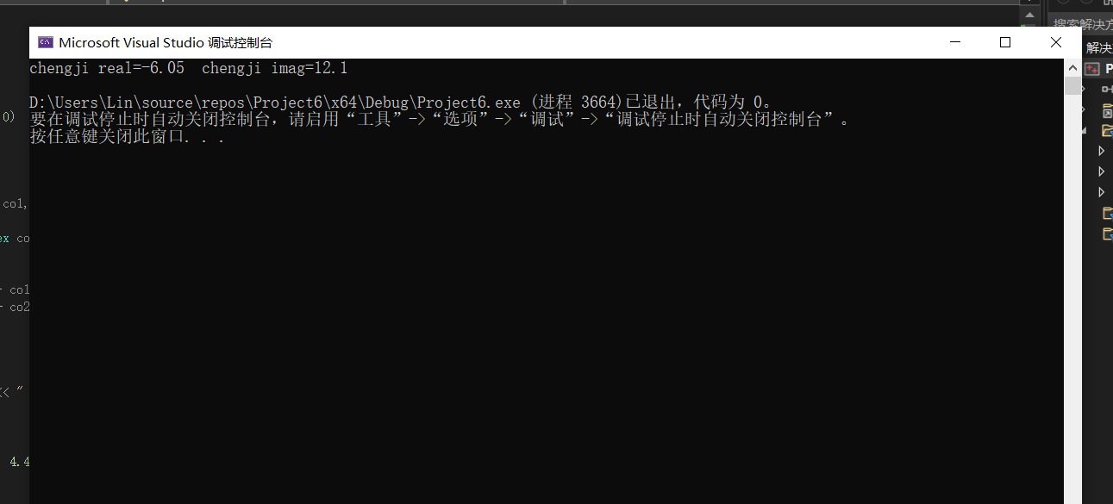

感想心得

通过本次实验，我掌握了c++多态性的基本概念，且理解了一点运算符重载函数的声明和定义方法。这方面的内容相较于之前比较容易，可以通过修改例题达成目标。但是多态作为三大特性之一，我们应该好好学习它。